Why Is Everything in the Bookstore So Expensive? The Logo Tax Behind University Bookstore Luxury
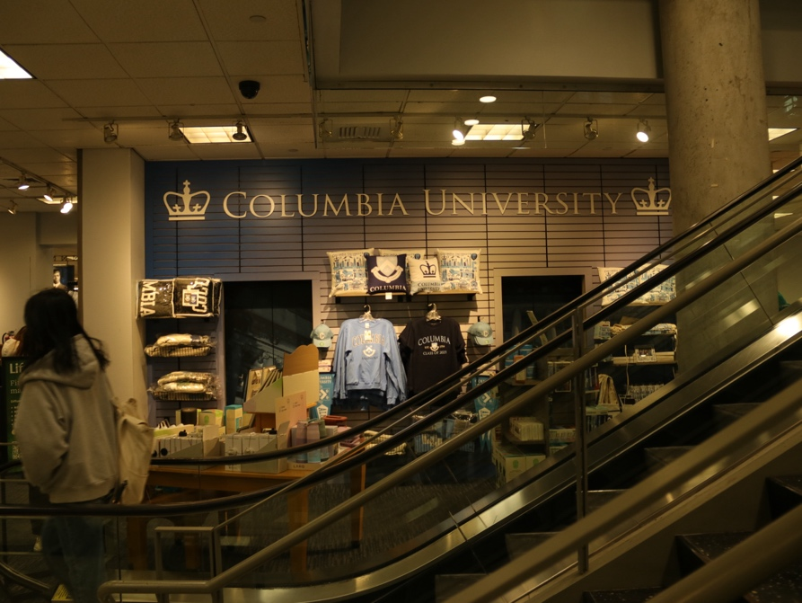
Columbia University’s latest bookstore collaboration with Lululemon has drawn student interest – and sticker shock. Students eagerly pulled Columbia-branded leggings and hoodies from gleaming racks. But the initial excitement died at the price tags – many walking away after a single glance at the cost.
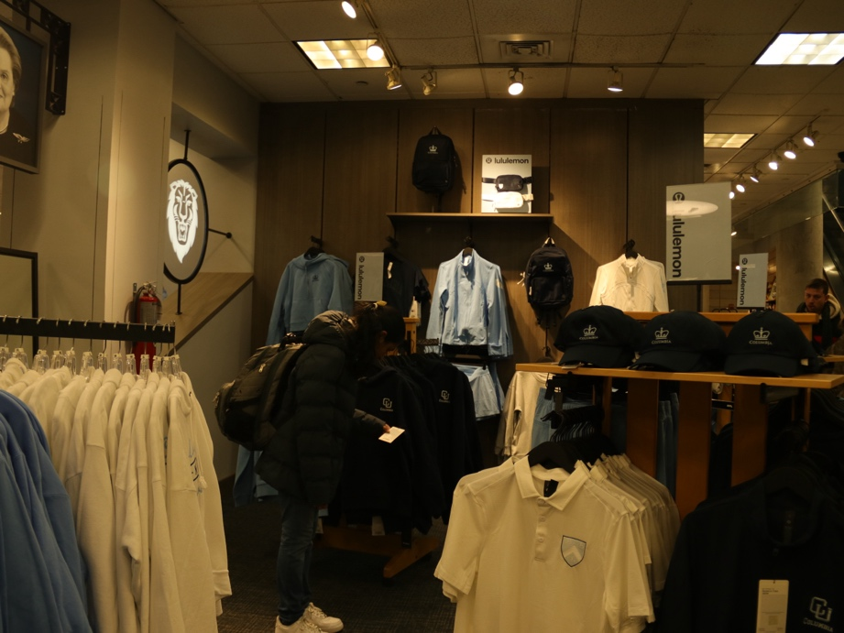
The data shows why: identical Lululemon items cost on average 36% more at the Columbia Bookstore than at regular Lululemon stores. The markup reaches extreme levels on certain items – the Everywhere Backpack, priced at $129.98, carries a striking 67% premium over Lululemon’s standard $78 price tag. Even a basic Cates Tee jumps from $48 to $74.98, a 56% increase.
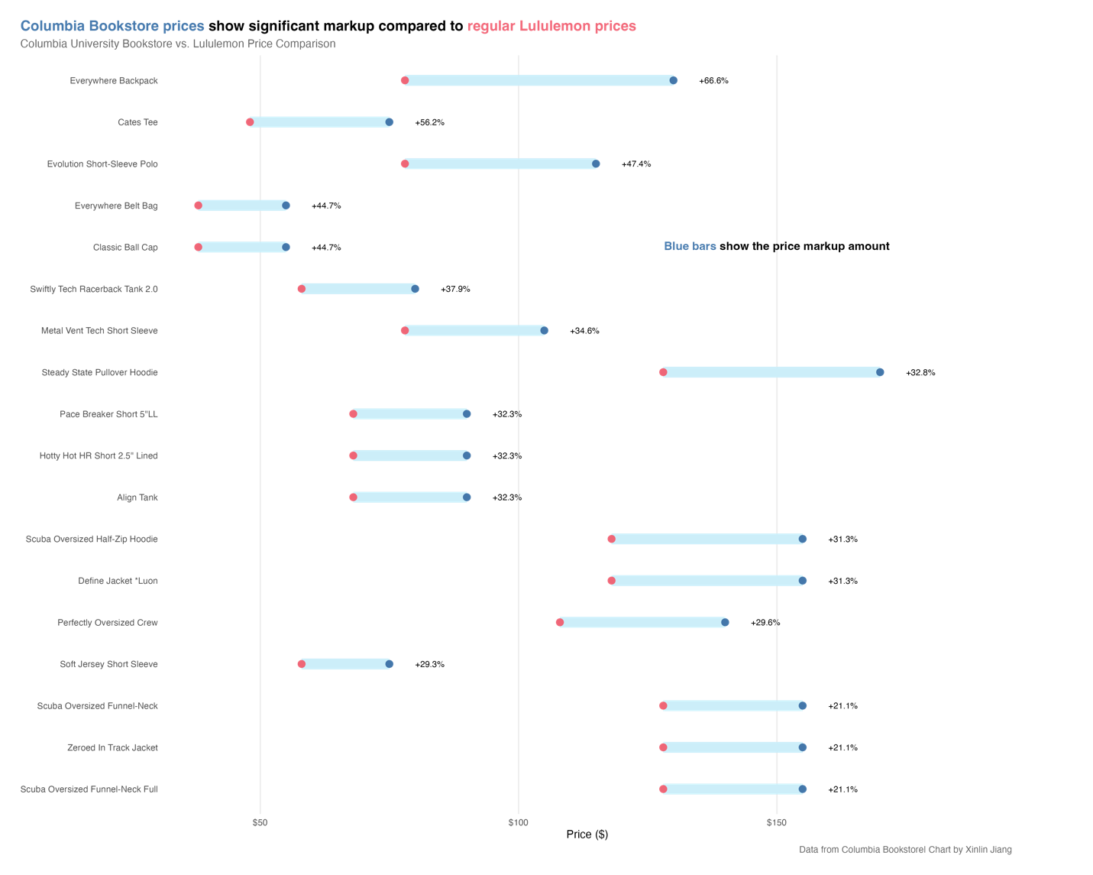
“The price is unreasonable,” said Kiko Zhong, a first-year graduate student at Columbia’s Graduate School of Arts and Sciences and a self-proclaimed Lululemon enthusiast. “The jacket is identical to Lululemon’s Define jacket -- the only difference is the logo.”
This premium pricing extends beyond the Lululemon collaboration. A comparison of New York City’s university bookstores shows Columbia leading the pack: the cheapest and basic outfit combination (hat, top, and bottoms) costs $80.96 at Columbia, while similar items at New York University run about $55.

In fact, this pattern repeats across the nation’s top universities.

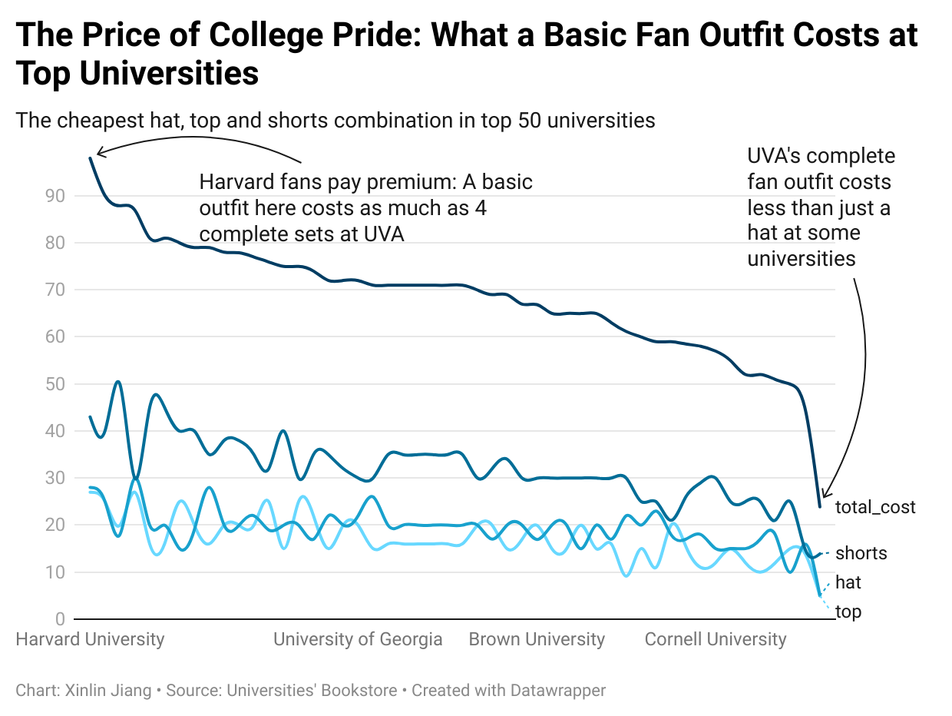
The price of college pride comes with a significant markup at university bookstores, with Ivy League institutions averaging $75.38 for their most basic fan outfit combination. This pricing trend shows a broader pattern in collegiate merchandise, where brand prestige directly influences cost.
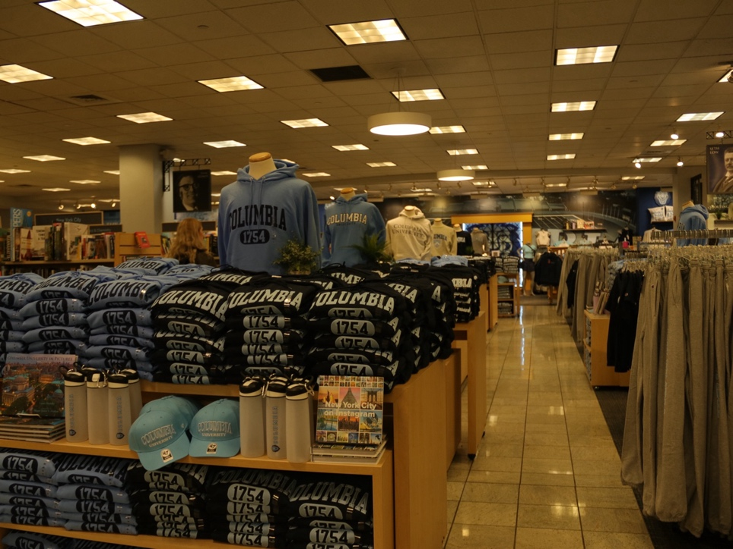
For Kiana Mehanian, a senior at Columbia College who regularly shops at the bookstore for school supplies, these prices have become a reluctant norm. Having lived in Los Angeles, San Francisco and New York – America’s most expensive cities – she’s grown accustomed to the premium pricing.
“Things wouldn’t cost as much if they didn’t have Columbia on it, but it’s pretty much every school I see,” Mehanian said. “It’s a little higher than I think it should be, but I honestly haven’t seen a university where that’s not the case.”
Maya Paul, a first-year medical student at Columbia, selected a sweater as birthday gift for herself. “I wish it (the price) was lower,” Paul said. “I usually know it’s gonna hit my wallet when I’m here.”

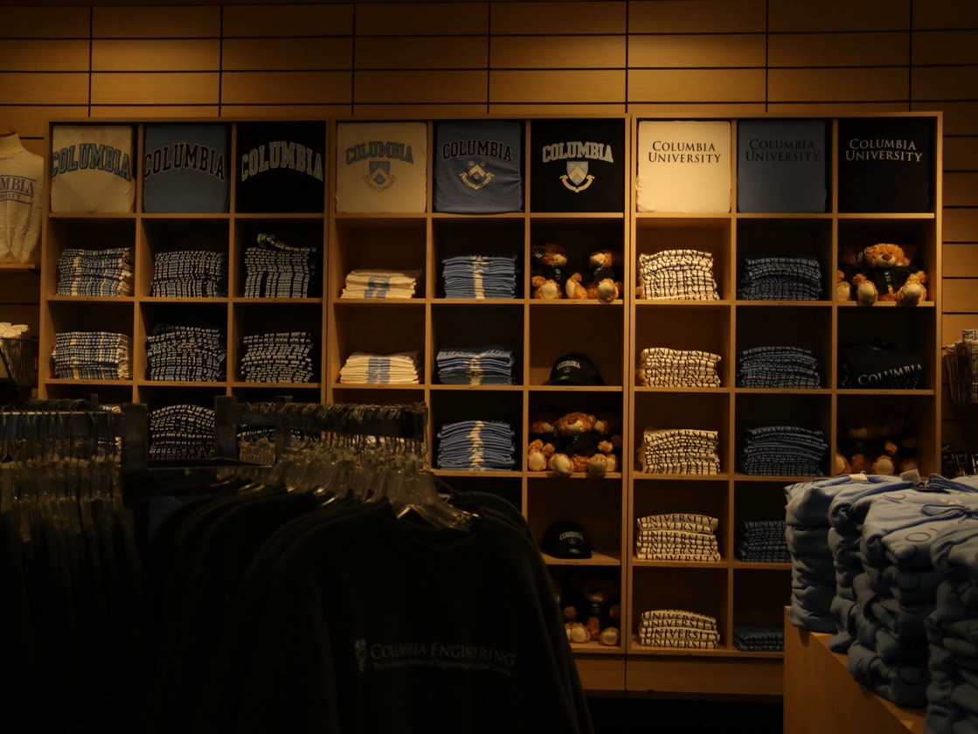
For many, a university bookstore represents more than just a retail space. It’s where dreams materialize into tangible symbols -- whether for hopeful high school students, proud parents or current students seeking to represent their school spirits.

Columbia is seen as a dream school by Grace Hyde, a high school student from Italy. She visited New York City with her family during winter break. Despite campus access being limited, a purchase from the bookstore was still desired. “I probably want to buy a sweatshirt, because I really like the prints, and I just want to have a memory that I will be using hopefully in the next years,” Hyde said.

The high prices don’t always translate to superior quality. Louis Schmidbauer, a visiting student from Germany, discovered this after purchasing several items. “I bought a jacket with loose strings and a sweater whose sleeves began unraveling,” he said. “The pricing doesn’t really align with the quality.”

The pricing pattern becomes clearer when examining the role of Barnes & Noble College, which operates many university bookstores. At 19 partner universities, identical adjustable hats with different logos are uniformly priced at $29.98. In contrast, universities operating independent bookstores, like Harvard, maintain lower prices, charging $18.89 for comparable hats. When contacted via email regarding their pricing strategy, Barnes & Noble College management went unanswered.

Take university pennants, a classic dorm room decoration: prices range from $26.99 at Stanford to just $6.99 at the University of Wisconsin-Madison -- a $20 difference for essentially identical items with different logos.

In response to these high bookstore prices, alternative retailers have emerged near campus locations. A prime example is Ivy League Stationers located across from Columbia University’s main gate on 116th Street and Broadway.
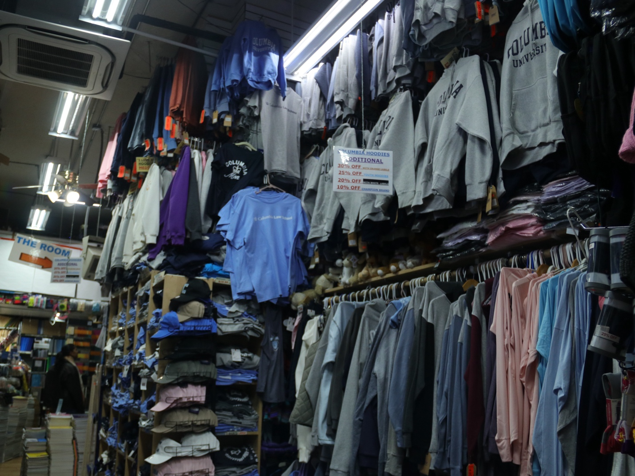
“We listen to customers. If they complain that the prices are high at the bookstore, we got to listen that they price sensitive,” said Justin Faye, the manager of the store.
The store maintains product authenticity while intentionally keeping prices at least 30 percent lower than the bookstore. Faye found the same designated suppliers that the bookstore collaborates with and sells identical products at a discount.
“Whenever Columbia puts their trademark logo on an item, it goes up because from the source, from the supplier, the price is bumped up,” Faye said.
His business strategy relies heavily on word-of-mouth: “If you were to buy something, you went to the bookstore, because it’s official, you see one price. You come in here, you see a little bit cheaper. You’re gonna go and tell all your friends, and that’s our marketing strategy.”
Faye acknowledges Columbia’s market positioning while emphasizing an often-overlooked reality: “Everybody at Columbia is not rich, I promise you. I know people come here and express that all the time.”

